Picture Gallery
Design Document

Data Schema
The following tables will be needed for the Picture Gallery:
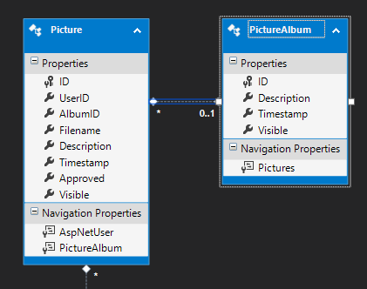
The above two tables “Picture” and “PictureAlbum” already exist in the “digiozPortalDB.edmx” which is an ADO.NET Entity Data Modelproject item. To update your local database with these two new tables, do the following:
- Get the latest version of the source code from GIT.
- Right-click on the “digioz.Portal.DB” project, and choose “Schema Compare”.
- In the “Select Target” drop down, Click on the arrow and chose “Select Target”.
- Select your local database, then click on “OK”.
- Click on the “Compare” button to compare the two databases.
- Review the recommended changes. Once satisfied, click on the “Update” button to update your database.

Admin Area
To access the admin area, log in using the following credentials:

Username: admin
Password: password

Once logged in, click on the “Admin Dashboard” link to take you to the Admin Area:

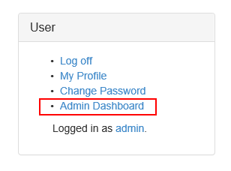
The Admin Dashboard is an MVC “Area” in the source code. Right click on the Admin/Controllers folder, and add a new MVC5 Controller using Entity Framework 6 to do the CRUD operation for both “Picture” and “PictureAlbum” (2 separate controllers). You should use the Scaffolding that comes with EF 6 to generate all the Actions and Pages.

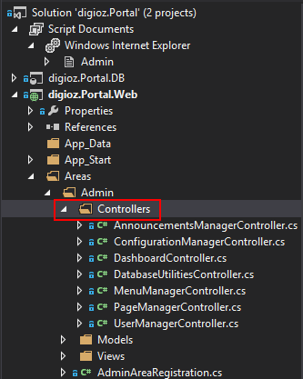

Name one of the two Controllers “PictureManagerController”, and the other “PictureAlbumManagerController”. The index action of “PictureManagerController” should have two options:

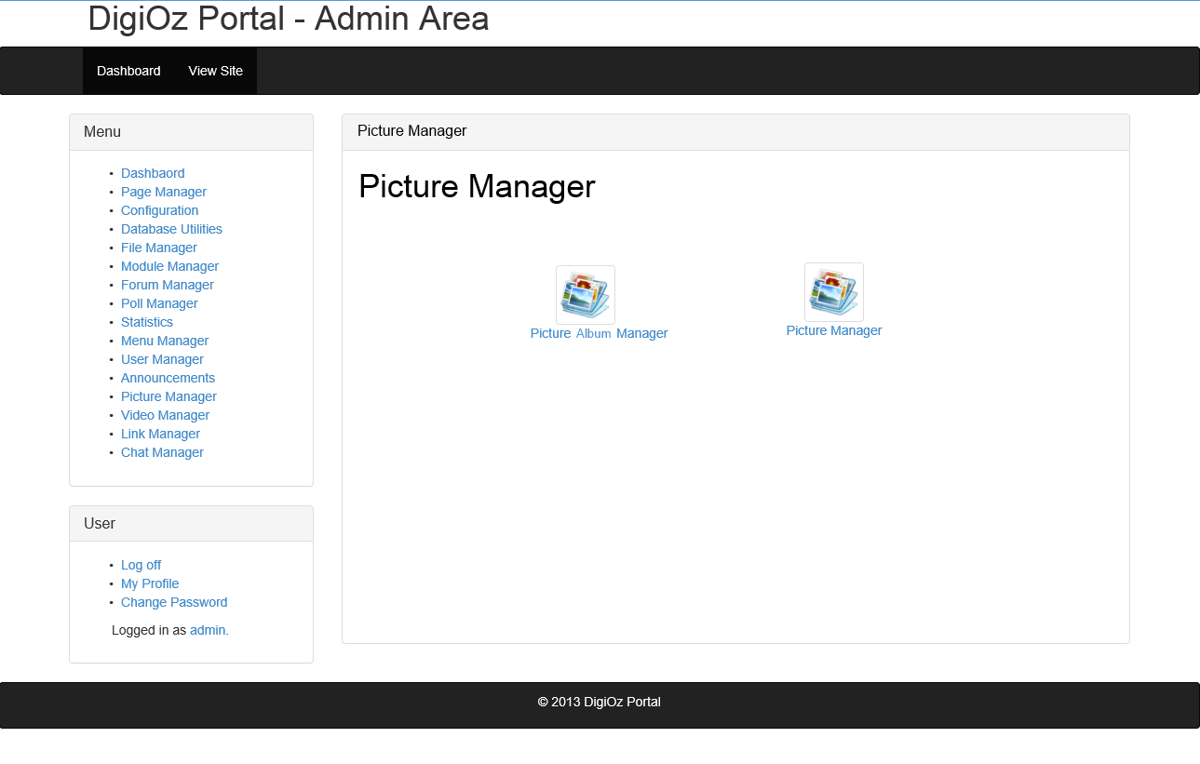

The “Picture Album Manager” will be a simple gridview with pagination, that looks like this:

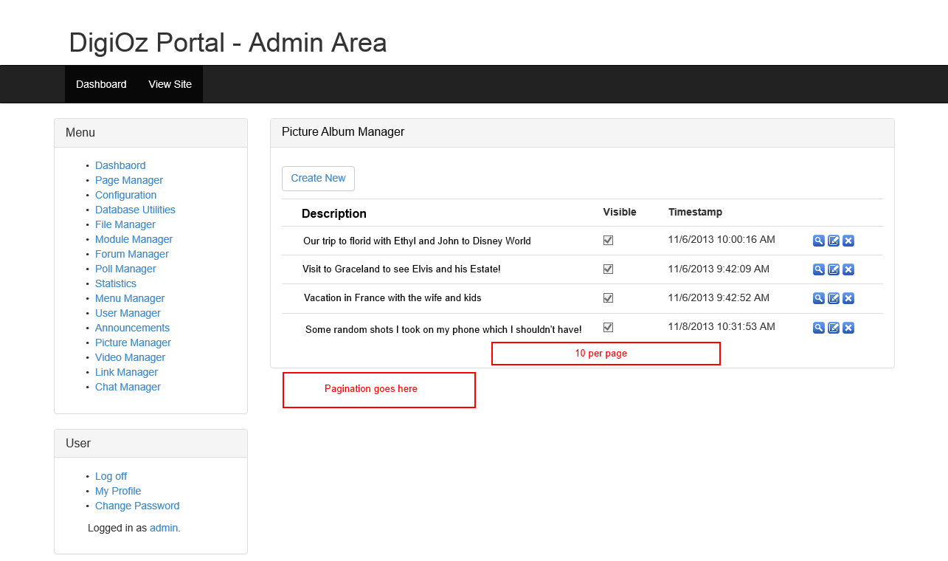

You will create a similar grid for the “Picture Manager”, with the exception that for the Picture Manager the first column will be the image thumbnail hyperlinked to the full sized image.

